Future Spartans,

I would like to take the opportunity to welcome all parents and players to another football season here at Deptford High School. There is a lot of information that was distributed to our players during our team meeting on Thursday, May 12. It is very important that you look at the information so that all of our players submit paperwork on time so that they are able to get going this season. I am forwarding all of the paperwork to you now so that you are up to speed with the things that are coming up. Key dates are quickly approaching and it is very important that the players have the support of everyone involved to help each player have a championship experience as a Spartan.

The excitement to the start of another season is upon us. We are ready to start the process of molding our young men into individuals that possess high character qualities that are evident in driven football players. We are striding to build a championship program that will represent the Spartan community proudly. The 2016 season is much anticipated and you are a key component that will make a difference for our players. We have a great group of young men that are here working to win the Group III Championship. Our program is in the process of reestablishing ourselves as one of rising football programs in South Jersey. We need to continue to replenish the football program with tough and committed individuals that want to be football players. Football is a sport that requires dedication and desire if you want to be successful. These are also the prerequisites that are necessary for you to be successful in life. As a Spartan you will learn to utilize the essential characteristics to be leaders on the field, leaders in the classroom and future leaders in our community.

Our players will need the full support of parents this season. Our Spartan Iron Man Competition is one month away so it is critical that all players take part in getting their donation letters out to raise money for their Spartan Pride Packs. Please review the Spartan Ironman Pledge Form. Every player will have the opportunity to get enough donations so that they will not have to pay one penny to play football here. If players choose not to take part in finding donations then they can choose the buy out option for their pride packs. I think they you will find that allowing each player to work hard on and off of the field will not only build character but also give them a greater appreciate for the hard work that is being done for them on their behalf.

On Friday June 10th at 5PM in Spartan Stadium will be having the Spartan Iron Man Competition Award Ceremony where we will be giving out awards for the strongest players. Immediately following the award ceremony we will be having a mandatory parent meeting in Spartan Stadium. If for some reason that a parent cannot make that meeting on Friday June 10th then the remaining parents will be expected to attend out Football Booster Club Meeting on Tuesday June 14th at 6PM in the high school cafeteria. All players will be tested for the Iron Man Lift and so we will have an alternate test date in early July to give every player the opportunity pay for their pride packs by getting donations in the community.

We encourage our players to strive to be the very best and it is evident that our program has had many successful past Spartans who have become leaders in our community. Your support for the players in the program is an essential component to building championship caliber student athletes that we can all be proud about. If you or your parents have any questions for me or about our program please contact me.

There are some important dates that you will need to pay attention to as the school year comes to an end and the summer begins:

*Physicals and Participation Formsdue by June 1st, 2016 (Needs completed forms to participate)
*Iron Man Compeition TestingMonday June 6th and Wednesday June 8th (Spartan Iron Man Awards Ceremony on Friday June 12th at 5pm in Spartan Stadium) Mandatory Parents Meeting to follow ceremony
Iron Man Competition Pays for Pride Packs

*7on7 Practice For Haddonfield Tournament Thursday June 16th, Friday 17th, at 2:30PM
* 7on7 HaddonfieldSaturday June 18th 2016
*Summer Workouts begin on Monday June 27th, 2016 at 3PM
*Practice in July will be Monday thru Thursday (Players are off Friday thru Sunday)
*Players are off from July 29th thru August 7th
*Football Campbegins August 8th, 2016

LET’S GO SPARTANS!

Chris Crowley
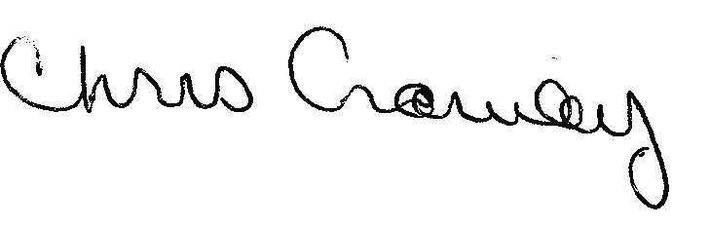

Head Football Coach
Deptford Spartans
(Office) 856 232-2713 Ext. 2520
www.deptfordspartansfootball.com
www.youtube.com/coachccrowley

